Ideation Phase
Empathize & Discover

Date | 25 June 2026
Project Name | EduGenie: AI-Powered Learning Assistant

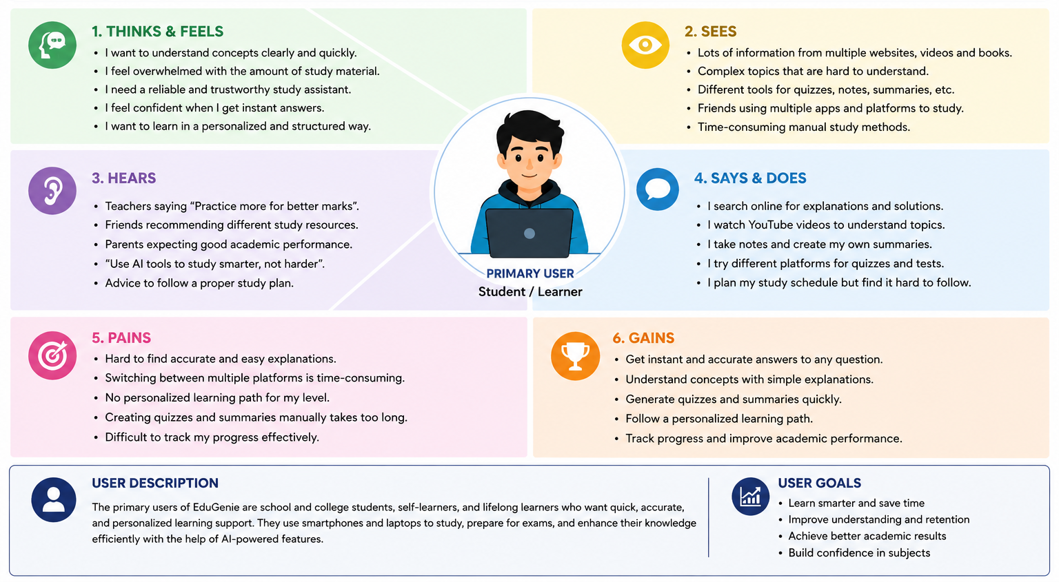

Empathy Map Canvas: EduGenie

An empathy map is a visual tool used to capture knowledge about a user's behaviors and attitudes to better understand their perspective, goals, and challenges.

SAYS  (What are some quotes and defining words your user said?) | THINKS  (What is the user thinking? What are their beliefs?)
DOES  (What actions and behaviors did you notice?) | FEELS  (What emotions might your user be feeling?)

